CHAPTER 9
Biomolecules
• Biomolecules

Class 11 - Chapter 9 - NEET replacement notes built from the NCERT chapter text, its 5 figures (15 panels), its 5 tables, its summary and its 11 exercises.
There is a wide diversity in living organisms in our biosphere. Are all living organisms made of the same chemicals, i.e., elements and compounds? Although there is a bewildering diversity of living organisms, their chemical composition and metabolic reactions appear to be remarkably similar.
If we perform a chemical analysis on a plant tissue, animal tissue or a microbial paste, we obtain a list of elements like carbon, hydrogen, oxygen and several others, and their respective content per unit mass of a living tissue. If the same analysis is performed on a piece of earth's crust as an example of non-living matter, we obtain a similar list. In absolute terms, no such differences could be made out; the elemental composition of living tissues and non-living matter appear also to be similar when analysed qualitatively.
All the elements present in a sample of earth's crust are also present in a sample of living tissue. However, a closer examination reveals that the relative abundance of carbon and hydrogen with respect to other elements is higher in any living organism than in earth's crust (Table 9.1); taken over the three elements together, the relative abundance of carbon, hydrogen and oxygen is higher in living systems when compared to inanimate matter.
Element | % Weight of Earth's crust | % Weight of Human body
Hydrogen (H) | 0.14 | 9.5
Carbon (C) | 0.03 | 18.5
Oxygen (O) | 46.6 | 65.0
Nitrogen (N) | very little | 3.3
Sulphur (S) | 0.03 | 0.3
Sodium (Na) | 2.8 | 0.2
Calcium (Ca) | 3.6 | 1.5
Magnesium (Mg) | 2.1 | 0.1
Silicon (Si) | 27.7 | negligible

Table 9.1 - A Comparison of Elements Present in Non-living and Living Matter. Adapted from CNR Rao, Understanding Chemistry, Universities Press, Hyderabad.
9.1 | How to Analyse Chemical Composition?

We wish to know what type of organic compounds are found in living organisms. How does one go about finding the answer? To get an answer, one has to perform a chemical analysis.
We can take any living tissue (a vegetable or a piece of liver, etc.) and grind it in trichloroacetic acid (Cl3CCOOH) using a mortar and a pestle. We obtain a thick slurry. If we were to strain this through a cheesecloth or cotton we would obtain two fractions.
• One is called the filtrate or, more technically, the acid-soluble pool, and the second, the retentate or the acid-insoluble fraction. Scientists have found thousands of organic compounds in the acid-soluble pool.
To identify a compound, one extracts the compounds, then subjects the extract to various separation techniques till one has separated a compound from all other compounds. In other words, one isolates and purifies a compound. Analytical techniques, when applied to the compound, give us an idea of the molecular formula and the probable structure of the compound.
• All the carbon compounds that we get from living tissues can be called biomolecules. However, living organisms have also got inorganic elements and compounds in them.
Finding the inorganic constituents. A slightly different but destructive experiment has to be done. One weighs a small amount of a living tissue (say a leaf or liver - this is called wet weight) and dries it. All the water evaporates; the remaining material gives the dry weight. Now if the tissue is fully burnt, all the carbon compounds are oxidised to gaseous form (CO2, water vapour) and are removed. What is remaining is called 'ash'.
This ash contains inorganic elements (like calcium, magnesium etc). Inorganic compounds like sulphate, phosphate, etc., are also seen in the acid-soluble fraction. Therefore elemental analysis gives elemental composition of living tissues in the form of hydrogen, oxygen, chlorine, carbon etc. while analysis for compounds gives an idea of the kind of organic (Figure 9.1) and inorganic (Table 9.2) constituents present in living tissues.
Component | Formula
Sodium | Na+
Potassium | K+
Calcium | Ca++
Magnesium | Mg++
Water | H2O
Compounds | NaCl, CaCO3, PO4 3-, SO4 2-

Table 9.2 - A List of Representative Inorganic Constituents of Living Tissues.
From a chemistry point of view, one can identify functional groups like aldehydes, ketones, aromatic compounds, etc. But from a biological point of view, we shall classify them into amino acids, nucleotide bases, fatty acids etc.
Amino acids are organic compounds containing an amino group and an acidic group as substituents on the same carbon, i.e., the alpha-carbon. Hence, they are called alpha-amino acids.

They are substituted methanes. There are four substituent groups occupying the four valency positions: these are hydrogen, carboxyl group, amino group and a variable group designated as R group. Based on the nature of the R group there are many amino acids.
However, those which occur in proteins are only of twenty types. The R group in these proteinaceous amino acids could be a hydrogen (the amino acid is called glycine), a methyl group (alanine), hydroxy methyl (serine), etc. Three of the twenty are shown in Figure 9.1.
The chemical and physical properties of amino acids are essentially of the amino, carboxyl and the R functional groups. Based on the number of amino and carboxyl groups, there are acidic (e.g., glutamic acid), basic (lysine) and neutral (valine) amino acids. Similarly, there are aromatic amino acids (tyrosine, phenylalanine, tryptophan).
A particular property of amino acids is the ionizable nature of the -NH2 and -COOH groups. Hence in solutions of different pH, the structure of amino acids changes: in the intermediate protonation state (structure B of the inline scheme), both groups are ionised and the molecule is a dipolar ion - this is called the zwitterionic form.
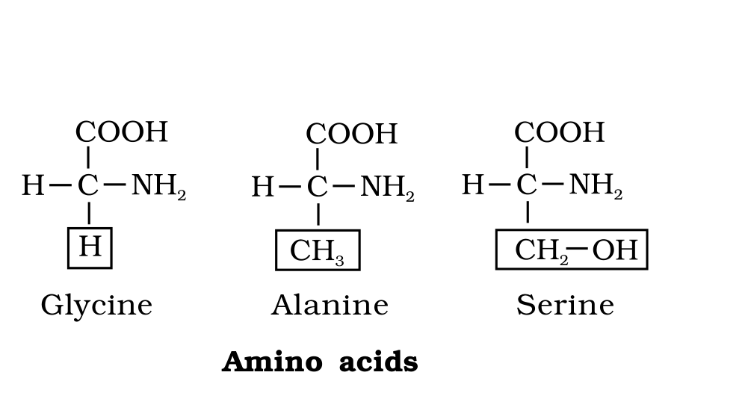
Fig. 9.1 (b) - Amino acids: three of the twenty proteinaceous amino acids (glycine, alanine, serine), each an alpha-amino acid built on a substituted methane.
Labels printed in the figure: Amino acids; Glycine; Alanine; Serine
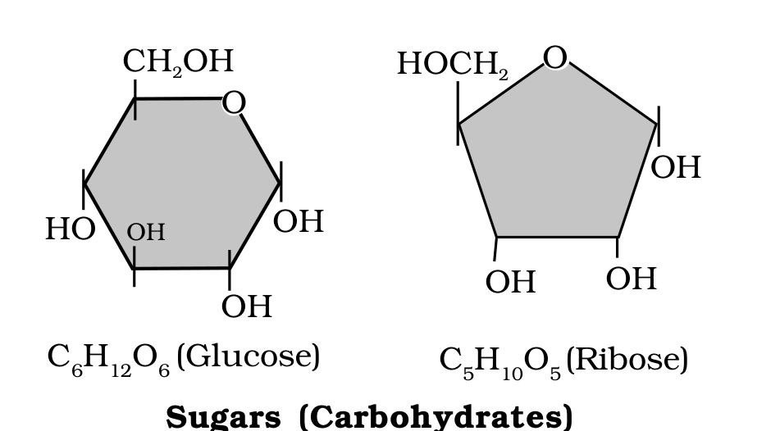
Fig. 9.1 (a) - Sugars (carbohydrates): glucose (C6H12O6) and ribose (C5H10O5), the small-molecular-weight sugars of living tissue.
Labels printed in the figure: Sugars (Carbohydrates); Glucose; Ribose
9.1 | Lipids

Lipids are generally water insoluble. They could be simple fatty acids. A fatty acid has a carboxyl group attached to an R group.
The R group could be a methyl (-CH3), or ethyl (-C2H5) or a higher number of -CH2 groups (1 carbon to 19 carbons). For example, palmitic acid has 16 carbons including the carboxyl carbon; arachidonic acid has 20 carbon atoms including the carboxyl carbon. Fatty acids could be saturated (without double bond) or unsaturated (with one or more C=C double bonds).
Another simple lipid is glycerol which is trihydroxy propane. Many lipids have both glycerol and fatty acids; here the fatty acids are found esterified with glycerol. They can then be monoglycerides, diglycerides and triglycerides. These are also called fats and oils based on melting point. Oils have lower melting point (e.g., gingelly oil) and hence remain as oil in winters. Can you identify a fat from the market?
Some lipids have phosphorous and a phosphorylated organic compound in them. These are phospholipids. They are found in cell membrane; lecithin is one example. Some tissues, especially the neural tissues, have lipids with more complex structures.
Fats and oils are glycerides in which fatty acids are esterified to glycerol; phospholipids contain, in addition, a phosphorylated nitrogenous compound.
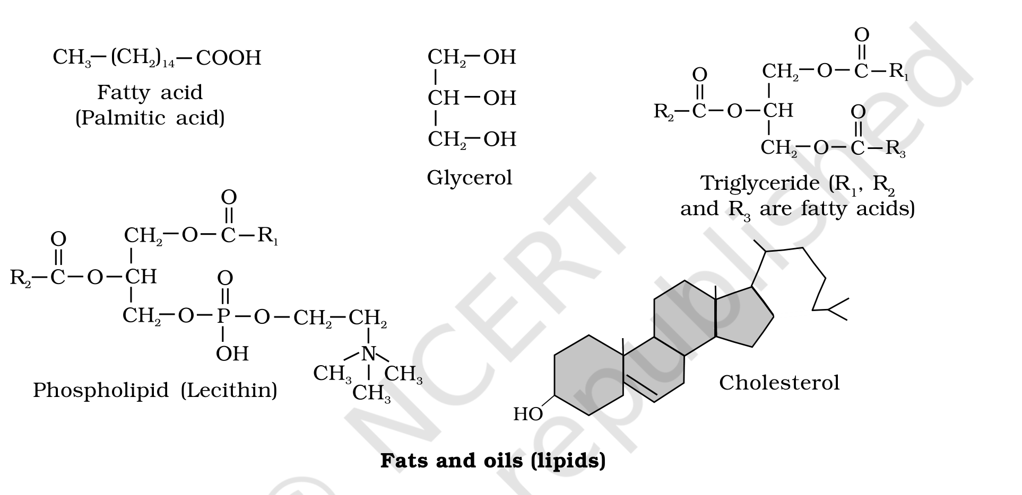
Fig. 9.1 (c) - Fats and oils (lipids): a fatty acid (palmitic acid), glycerol, a triglyceride (R1, R2, R3 are fatty acids), a phospholipid (lecithin) and cholesterol.
Labels printed in the figure: Fats and oils (lipids); Fatty acid; Palmitic acid; Glycerol; Triglyceride; are fatty acids; Phospholipid (Lecithin); Cholesterol
9.1 | Nitrogen Bases, Nucleosides and Nucleotides

Living organisms have a number of carbon compounds in which heterocyclic rings can be found. Some of these are nitrogen bases - adenine, guanine, cytosine, uracil, and thymine.
• When found attached to a sugar, they are called nucleosides. If a phosphate group is also found esterified to the sugar they are called nucleotides.
Adenosine, guanosine, thymidine, uridine and cytidine are nucleosides. Adenylic acid, thymidylic acid, guanylic acid, uridylic acid and cytidylic acid are nucleotides. Nucleic acids like DNA and RNA consist of nucleotides only. DNA and RNA function as genetic material.
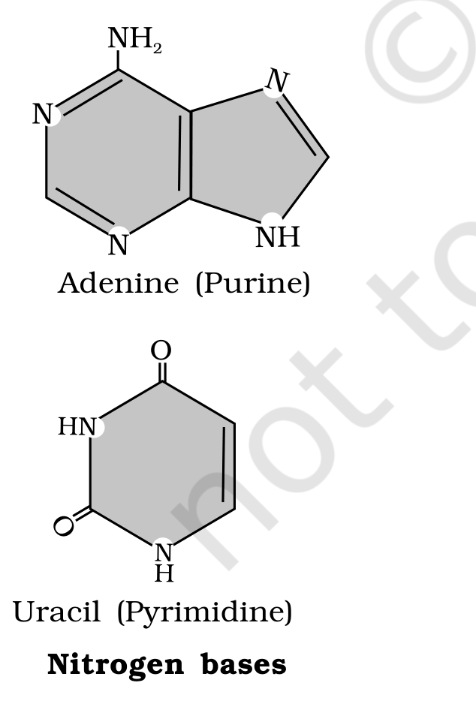
Fig. 9.1 (d) - Nitrogen bases: adenine (a purine) and uracil (a pyrimidine).
Labels printed in the figure: Nitrogen bases; Adenine (Purine); Uracil (Pyrimidine)
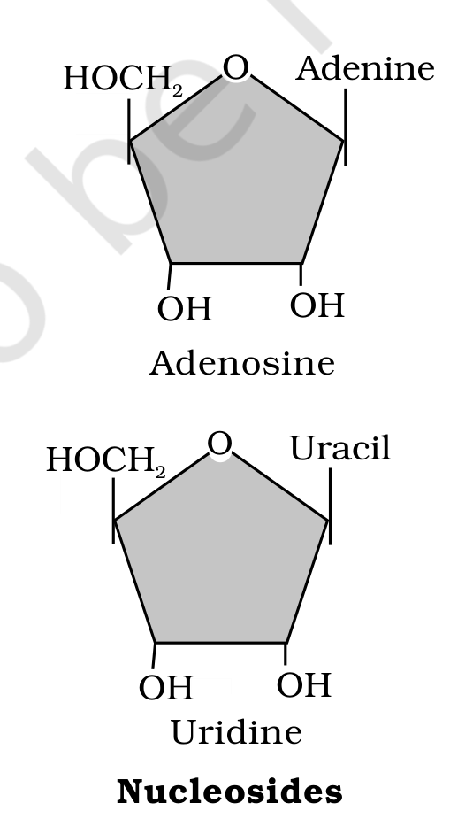
Fig. 9.1 (e) - Nucleosides: a base attached to a sugar - adenine gives adenosine, uracil gives uridine.
Labels printed in the figure: Nucleosides; Adenine; Adenosine; Uracil; Uridine
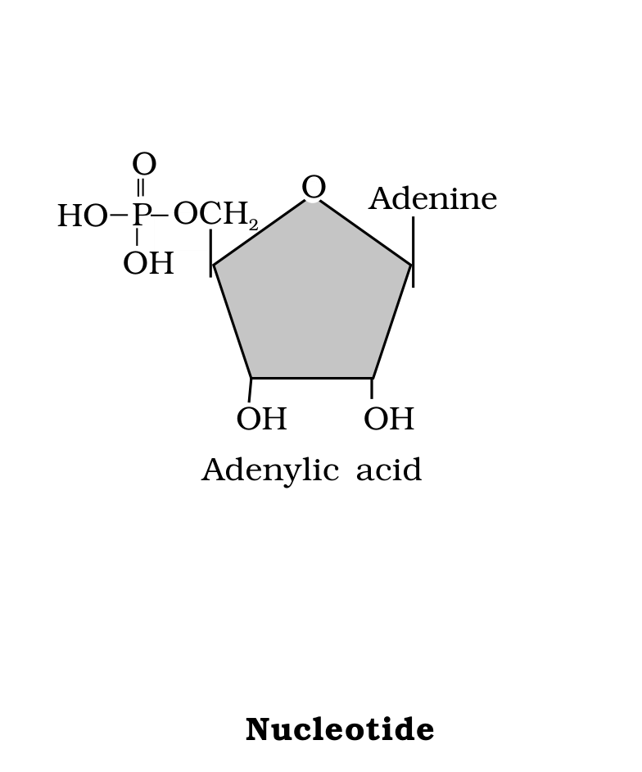
Fig. 9.1 (f) - Nucleotide: a base and sugar with a phosphate esterified to the sugar - adenine gives adenylic acid.
Labels printed in the figure: Nucleotide; Adenine; Adenylic acid
Figure 9.1 - Diagrammatic representation of small molecular weight organic compounds in living tissues.
Amino acids, monosaccharide and disaccharide sugars, fatty acids, glycerol, nucleotides, nucleosides and nitrogen bases are some of the organic compounds seen in living organisms.
9.2 | Primary and Secondary Metabolites

The most exciting aspect of chemistry deals with isolating thousands of compounds, small and big, from living organisms, determining their structure and if possible synthesising them.
• If one were to make a list of biomolecules, such a list would have thousands of organic compounds including amino acids, sugars, etc. We can call these biomolecules 'metabolites'.
In animal tissues, one notices the presence of all such categories of compounds shown in Figure 9.1. These are primary metabolites. However, when one analyses plant, fungal and microbial cells, one would see thousands of compounds other than these primary metabolites - e.g. alkaloids, flavonoids, rubber, essential oils, antibiotics, coloured pigments, scents, gums, spices. These are called secondary metabolites.
While primary metabolites have identifiable functions and play known roles in normal physiological processes, we do not, at the moment, understand the role or functions of all the secondary metabolites in host organisms. However, many of them are useful to human welfare (e.g., rubber, drugs, spices, scents and pigments). Some secondary metabolites have ecological importance.
Class of secondary metabolite | Examples
Pigments | Carotenoids, Anthocyanins, etc.
Alkaloids | Morphine, Codeine, etc.
Terpenoides | Monoterpenes, Diterpenes, etc.
Essential oils | Lemon grass oil, etc.
Toxins | Abrin, Ricin
Lectins | Concanavalin A
Drugs | Vinblastin, curcumin, etc.
Polymeric substances | Rubber, gums, cellulose

Table 9.3 - Some Secondary Metabolites.
9.3 | Biomacromolecules

There is one feature common to all those compounds found in the acid-soluble pool: they have molecular weights ranging from 18 to around 800 daltons (Da) approximately. The acid-insoluble fraction has only four types of organic compounds, i.e., proteins, nucleic acids, polysaccharides and lipids.
These classes of compounds - with the exception of lipids - have molecular weights in the range of ten thousand daltons and above. This is the basis of the acid-soluble/acid-insoluble divide:
• Those which have molecular weights less than one thousand daltons are usually referred to as micromolecules or simply biomolecules, while those found in the acid-insoluble fraction are called macromolecules or biomacromolecules. There are thousands of such small molecular weight biomolecules, all under 1000 Da.
The molecules in the insoluble fraction, with the exception of lipids, are polymeric substances. Then why do lipids, whose molecular weights do not exceed 800 Da, come under the acid-insoluble (macromolecular) fraction?
[NOTE] Lipids are indeed small molecular weight compounds and are present not only as such but also arranged into structures like cell membrane and other membranes. When we grind a tissue, we disrupt the cell structure: cell membrane and other membranes are broken into pieces and form vesicles which are not water soluble. Therefore these membrane fragments, in the form of vesicles, get separated along with the acid-insoluble pool and hence appear in the macromolecular fraction. For this reason lipids are not strictly macromolecules - which is why the chapter summary counts only three true macromolecules (proteins, nucleic acids and polysaccharides) even though the acid-insoluble fraction holds four classes of organic compound.

The acid-soluble pool represents roughly the cytoplasmic composition. The macromolecules from cytoplasm and organelles become the acid-insoluble fraction. Together they represent the entire chemical composition of living tissues or organisms. In summary, if we represent the chemical composition of living tissue from an abundance point of view and arrange them class-wise, we observe that water is the most abundant chemical in living organisms.
Component | % of the total cellular mass
Water | 70-90
Proteins | 10-15
Carbohydrates | 3
Lipids | 2
Nucleic acids | 5-7
Ions | 1

Table 9.4 - Average Composition of Cells.
Proteins are polypeptides. They are linear chains of amino acids linked by peptide bonds as shown in Figure 9.3. Each protein is a polymer of amino acids.

As there are 20 types of amino acids (e.g., alanine, cysteine, proline, tryptophan, lysine, etc.), a protein is a heteropolymer and not a homopolymer. A homopolymer has only one type of monomer repeating 'n' number of times.
• Certain amino acids are essential for our health and they have to be supplied through our diet. Hence, dietary proteins are the source of essential amino acids. Amino acids can be essential or non-essential: the non-essential ones are those which our body can make, while we get essential amino acids through our diet/food.
Proteins carry out many functions in living organisms: some transport nutrients across the cell membrane, some fight infectious organisms, some are hormones, some are enzymes, etc. Many of them are enzymes, some are antibodies, some are receptors, some are hormones and some others are structural proteins.
Collagen is the most abundant protein in the animal world, and Ribulose bisphosphate Carboxylase-Oxygenase (RuBisCO) is the most abundant protein in the whole of the biosphere.
Protein | Functions
Collagen | Intercellular ground substance
Trypsin | Enzyme
Insulin | Hormone
Antibody | Fights infectious agents
Receptor | Sensory reception (smell, taste, hormone, etc.)
GLUT-4 | Enables glucose transport into cells

Table 9.5 - Some Proteins and their Functions.
9.5 | Polysaccharides

The acid-insoluble pellet also has polysaccharides (carbohydrates) as another class of macromolecules. Polysaccharides are long chains of sugars - they are threads (literally a cotton thread) containing different monosaccharides as building blocks.
For example, cellulose is a polymeric polysaccharide consisting of only one type of monosaccharide, i.e., glucose; cellulose is a homopolymer. Starch is a variant of this but present as a store house of energy in plant tissues. Animals have another variant called glycogen. Inulin is a polymer of fructose.
• In a polysaccharide chain (say glycogen), the right end is called the reducing end and the left end is called the non-reducing end. It has branches, as shown in the form of a cartoon (Figure 9.2).
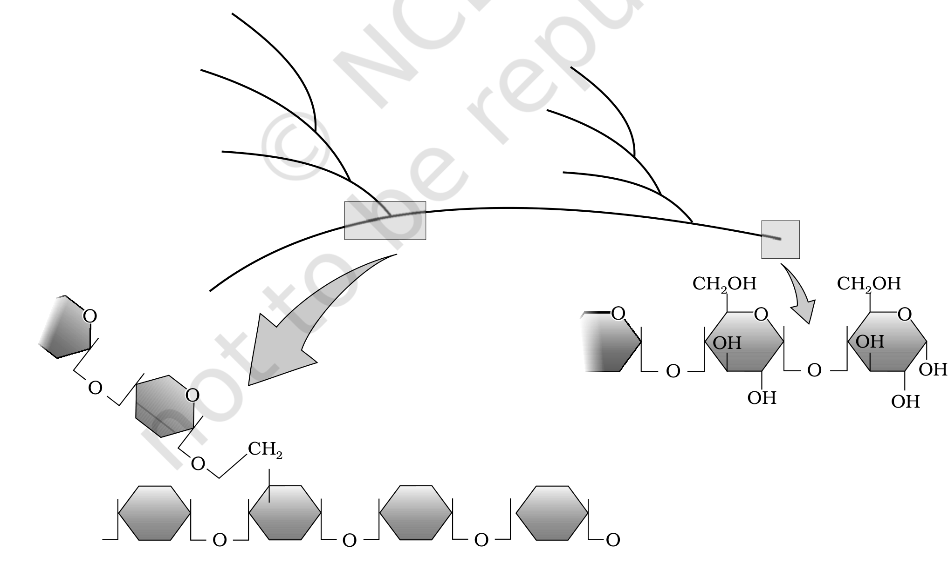
Fig. 9.2 - Diagrammatic representation of a portion of glycogen, a branched polysaccharide, showing its reducing and non-reducing ends.
Labels printed in the figure: glycogen
Starch, iodine and cellulose. Starch forms helical secondary structures. In fact, starch can hold I2 molecules in the helical portion; the starch-I2 is blue in colour. Cellulose does not contain complex helices and hence cannot hold I2.
Plant cell walls are made of cellulose. Paper made from plant pulp and cotton fibre is cellulosic. There are more complex polysaccharides in nature: they have as building blocks amino-sugars and chemically modified sugars (e.g., glucosamine, N-acetyl galactosamine, etc.). Exoskeletons of arthropods, for example, have a complex polysaccharide called chitin. These complex polysaccharides are mostly homopolymers.
[NOTE] Taken together: polysaccharides are components of the cell wall in plants and fungi and also of the exoskeleton of arthropods, and they are storage forms of energy (e.g., starch and glycogen).

9.6 | Nucleic Acids

The other type of macromolecule that one would find in the acid-insoluble fraction of any living tissue is the nucleic acid. These are polynucleotides. Together with polysaccharides and polypeptides these comprise the true macromolecular fraction of any living tissue or cell.
• For nucleic acids, the building block is a nucleotide. A nucleotide has three chemically distinct components: one is a heterocyclic compound, the second is a monosaccharide and the third a phosphoric acid or phosphate.
As you notice in Figure 9.1, the heterocyclic compounds in nucleic acids are the nitrogenous bases named adenine, guanine, uracil, cytosine, and thymine. Adenine and Guanine are substituted purines while the rest are substituted pyrimidines. The skeletal heterocyclic ring is called purine and pyrimidine respectively.
The sugar found in polynucleotides is either ribose (a monosaccharide pentose) or 2' deoxyribose. A nucleic acid containing deoxyribose is called deoxyribonucleic acid (DNA) while that which contains ribose is called ribonucleic acid (RNA).
Across all living organisms there are 20 types of amino acids and 5 types of nucleotides.
[NOTE] Nucleic acids serve as genetic material: DNA and RNA carry hereditary information and are passed on from the parental generation to the progeny.

9.7 | Structure of Proteins

Proteins, as mentioned earlier, are heteropolymers containing strings of amino acids. Structure of molecules means different things in different contexts.
In inorganic chemistry, the structure invariably refers to the molecular formulae (e.g., NaCl, MgCl2, etc.). Organic chemists always write a two-dimensional view of the molecules while representing their structure (e.g., benzene, naphthalene, etc.). Physicists conjure up the three-dimensional views of molecular structures, while biologists describe the protein structure at four levels.
• The sequence of amino acids - i.e., the positional information in a protein, which is the first amino acid, which is second, and so on - is called the primary structure (Figure 9.3 a) of a protein.
A protein is imagined as a line, the left end represented by the first amino acid and the right end represented by the last amino acid. The first amino acid is also called the N-terminal amino acid; the last amino acid is called the C-terminal amino acid.
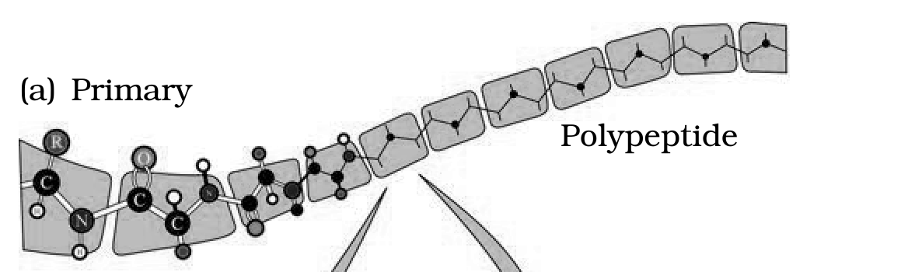
Fig. 9.3 (a) - Primary structure: a polypeptide, the linear sequence of amino acids from the N-terminal to the C-terminal end.
Labels printed in the figure: Primary; Polypeptide
A protein thread does not exist throughout as an extended rigid rod. The thread is folded in the form of a helix (similar to a revolving staircase). Of course, only some portions of the protein thread are arranged in the form of a helix; in proteins, only right-handed helices are observed. Other regions of the protein thread are folded into other forms in what is called the secondary structure (Fig. 9.3 b).
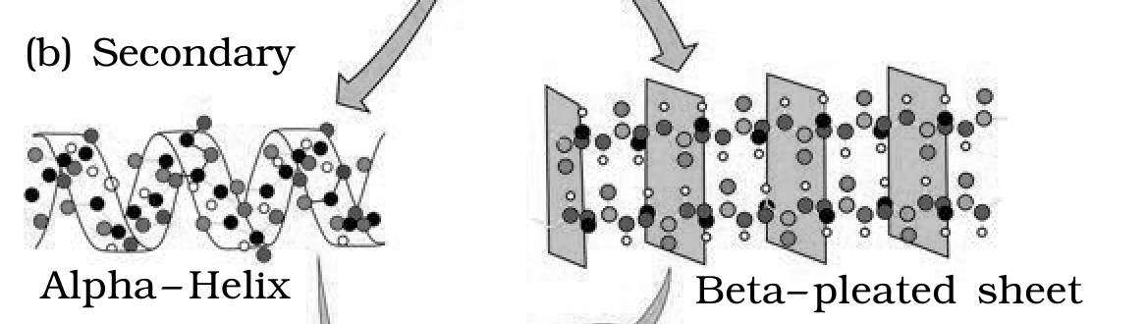
Fig. 9.3 (b) - Secondary structure: regions folded as the right-handed alpha-helix and the beta-pleated sheet.
Labels printed in the figure: Secondary; Alpha- Helix; Beta-pleated sheet
In addition, the long protein chain is also folded upon itself like a hollow woollen ball, giving rise to the tertiary structure (Fig. 9.3 c). This gives us a 3-dimensional view of a protein. Tertiary structure is absolutely necessary for the many biological activities of proteins.
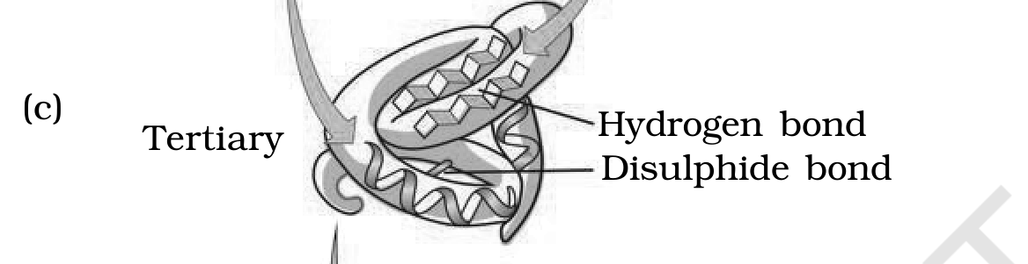
Fig. 9.3 (c) - Tertiary structure: the whole chain folded upon itself into a 3-D shape, held by hydrogen bonds and disulphide bonds.
Labels printed in the figure: Tertiary; Hydrogen bond; Disulphide bond
Some proteins are an assembly of more than one polypeptide or subunits. The manner in which these individual folded polypeptides or subunits are arranged with respect to each other (e.g. a linear string of spheres, or spheres arranged one upon each other in the form of a cube or plate, etc.) is the architecture of a protein, otherwise called the quaternary structure (Fig. 9.3 d).
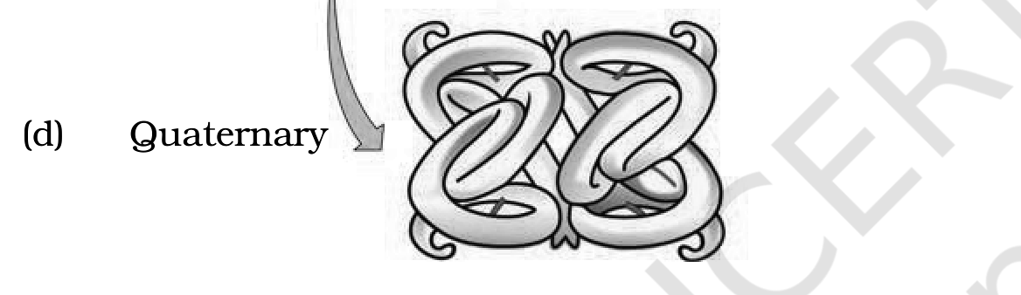
Fig. 9.3 (d) - Quaternary structure: the arrangement of several folded subunits with respect to one another.
Labels printed in the figure: Quaternary
Figure 9.3 - Various levels of Protein Structure.
Adult human haemoglobin consists of 4 subunits. Two of these are identical to each other. Hence, two subunits of alpha type and two subunits of beta type together constitute the human haemoglobin (Hb).
[MEMORY AID - not in NCERT] Four levels of protein structure - Primary = sequence (which amino acid is first, second, ...); Secondary = right-handed alpha-helix and beta-pleated sheet; Tertiary = whole chain folded like a woollen ball (needed for biological activity); Quaternary = several subunits assembled together (e.g. haemoglobin's 2 alpha + 2 beta). This same hierarchy - primary, secondary, tertiary and quaternary - is described for biomacromolecules generally.

Almost all enzymes are proteins. There are some nucleic acids that behave like enzymes; these are called ribozymes.

One can depict an enzyme by a line diagram. An enzyme, like any protein, has a primary structure (amino acid sequence) and also the secondary and the tertiary structure. When you look at a tertiary structure upon itself, the chain criss-crosses itself and hence many crevices or pockets are made.
• One such pocket is the 'active site'. An active site of an enzyme is a crevice or pocket into which the substrate fits. Thus enzymes, through their active site, catalyse reactions at a high rate.
Enzyme catalysts differ from inorganic catalysts in many ways, but one major difference needs mention: inorganic catalysts work efficiently at high temperatures and high pressures, while enzymes get damaged at high temperatures (say above 40 degrees C). However, enzymes isolated from organisms who normally live under extremely high temperatures (e.g., hot vents and sulphur springs) are stable and retain their catalytic power even at high temperatures (up to 80-90 degrees C). Thermal stability is thus an important quality of such enzymes isolated from thermophilic organisms.
9.8.1 | Chemical Reactions

Chemical compounds undergo two types of changes. A physical change simply refers to a change in shape without breaking of bonds - this is a physical process. Another physical process is a change in the state of matter: when ice melts into water, or when water becomes vapour.
• However, when bonds are broken and new bonds are formed during transformation, this is called a chemical reaction. For example, Ba(OH)2 + H2SO4 -> BaSO4 + 2H2O is an inorganic chemical reaction; similarly, hydrolysis of starch into glucose is an organic chemical reaction.
Rate of a physical or chemical process refers to the amount of product formed per unit time: rate = delta P / delta t. Rate can also be called velocity if the direction is specified. Rates of physical and chemical processes are influenced by temperature among other factors: a general rule of thumb is that rate doubles or decreases by half for every 10 degrees C change in either direction.
Catalysed reactions proceed at rates vastly higher than that of uncatalysed ones. When enzyme-catalysed reactions are observed, the rate is vastly higher than the same but uncatalysed reaction.
[NOTE] Take CO2 + H2O -> H2CO3 (carbon dioxide + water -> carbonic acid). In the absence of any enzyme this reaction is very slow, with about 200 molecules of H2CO3 being formed in an hour. However, using the enzyme present within the cytoplasm called carbonic anhydrase, the reaction speeds dramatically with about 600,000 molecules being formed every second - the enzyme has accelerated the reaction rate by about 10 million times. The power of enzymes is incredible indeed!

• There are thousands of types of enzymes, each catalysing a unique chemical or metabolic reaction. A multistep chemical reaction, when each of the steps is catalysed by the same enzyme complex or by different enzymes, is called a metabolic pathway.
For example, Glucose -> 2 Pyruvic acid (C6H12O6 + O2 -> 2 C3H4O3 + 2 H2O) is actually a metabolic pathway in which glucose becomes pyruvic acid through ten different enzyme-catalysed metabolic reactions. This very metabolic pathway, with one or two additional reactions, gives rise to a variety of metabolic end products.
In our skeletal muscle, under anaerobic conditions, lactic acid is formed. Under normal aerobic conditions, pyruvic acid is formed. In yeast, during fermentation, the same pathway leads to the production of ethanol (alcohol). Hence, in different conditions different products are possible.
The chemical or metabolic conversion referred to here is a reaction. The chemical which is converted into a product is called a 'substrate'. Enzymes - i.e. proteins with three-dimensional structures including an active site - convert a substrate (S) into a product (P). Symbolically: S -> P.

It is now understood that the substrate 'S' has to bind the enzyme at its active site within a given cleft or pocket. The substrate has to diffuse towards the active site. There is thus an obligatory formation of an 'ES' complex (E stands for enzyme); this complex formation is a transient phenomenon.
During the state where substrate is bound to the enzyme active site, a new structure of the substrate, called the transition state structure, is formed. Very soon, after the expected bond breaking/making is completed, the product is released from the active site. In other words, the structure of the substrate gets transformed into the structure of the product(s).
The pathway of this transformation must go through the transition state structure. There could be many more 'altered structural states' between the stable substrate and the product; implicit in this is the fact that all other intermediate structural states are unstable. Stability is something related to the energy status of the molecule or the structure.
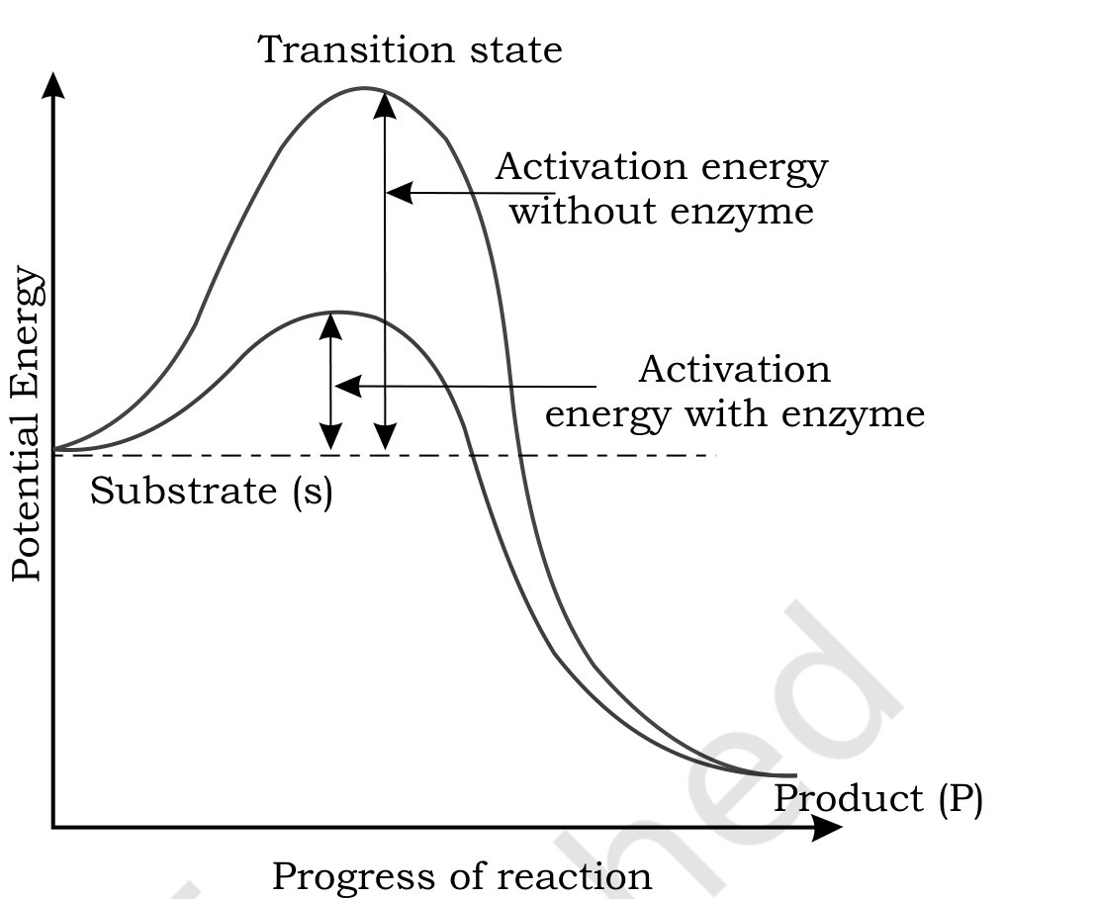
Fig. 9.4 - Concept of activation energy: potential energy rises from the substrate (S) to a high-energy transition state and falls to the product (P); the enzyme lowers the activation energy barrier.
Labels printed in the figure: Transition state; Activation energy without enzyme; Activation energy with enzyme; Potential Energy; Substrate (s); Product (P); Progress of reaction
In the graph, the y-axis represents the potential energy content and the x-axis represents the progression of the structural transformation or states through the transition state. Consider the energy-level difference between S and P: if 'P' is at a lower level than 'S', the reaction is an exothermic reaction and one need not supply energy (by heating) in order to form the product.
• However, whether it is an exothermic (spontaneous) reaction or an endothermic (energy-requiring) reaction, the 'S' has to go through a much higher energy state or transition state. The difference in average energy content of 'S' from that of this transition state is called 'activation energy'. Enzymes eventually bring down this energy barrier, making the transition of 'S' to 'P' easier.
9.8.3 | Nature of Enzyme Action

Each enzyme (E) has a substrate (S) binding site in its molecule so that a highly reactive enzyme-substrate complex (ES) is produced. This complex is short-lived and dissociates into its product(s) P and the unchanged enzyme, with an intermediate formation of the enzyme-product complex (EP). The formation of the ES complex is essential for catalysis:
E + S -> ES -> EP -> E + P
1 | First, the substrate binds to the active site of the enzyme, fitting into the active site.
2 | The binding of the substrate induces the enzyme to alter its shape, fitting more tightly around the substrate.
3 | The active site, now in close proximity to the substrate, breaks the chemical bonds of the substrate and the new enzyme-product complex is formed.
4 | The enzyme releases the products of the reaction and the free enzyme is ready to bind to another substrate molecule and run through the catalytic cycle once again.

9.8.4 | Factors Affecting Enzyme Activity

The activity of an enzyme can be affected by a change in the conditions which can alter the tertiary structure of the protein. These include temperature, pH, change in substrate concentration or binding of specific chemicals that regulate its activity.
Enzymes generally function in a narrow range of temperature and pH (Figure 9.5). Each enzyme shows its highest activity at a particular temperature and pH called the optimum temperature and optimum pH. Activity declines both below and above the optimum value. (Proteinaceous enzymes thus exhibit substrate specificity and require optimum temperature and pH for maximal activity.)

Low temperature preserves the enzyme in a temporarily inactive state, whereas high temperature destroys enzymatic activity because proteins are denatured by heat.
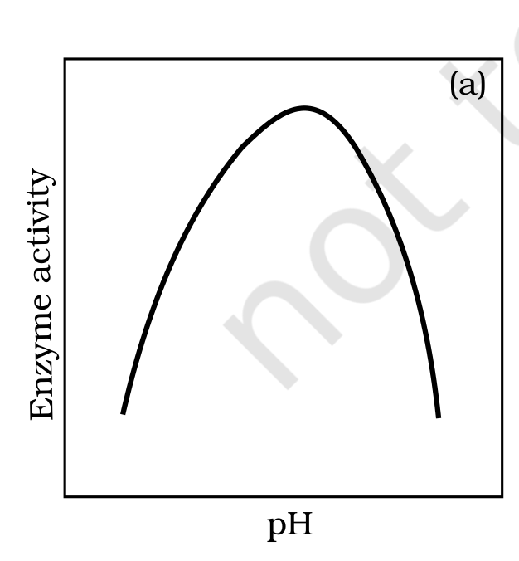
Fig. 9.5 (a) - Effect of change in pH on enzyme activity: activity peaks at the optimum pH and falls on either side.
Labels printed in the figure: Enzyme activity; pH
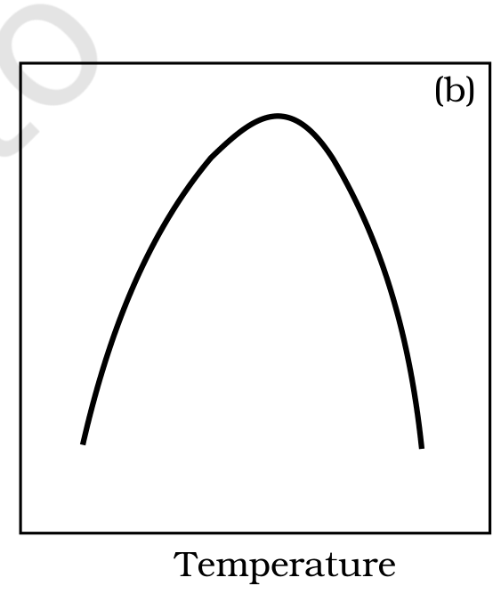
Fig. 9.5 (b) - Effect of change in temperature on enzyme activity: activity peaks at the optimum temperature and falls on either side.
Labels printed in the figure: Temperature
9.8.4 | Concentration of Substrate

With the increase in substrate concentration, the velocity of the enzymatic reaction rises at first. The reaction ultimately reaches a maximum velocity (Vmax) which is not exceeded by any further rise in the concentration of the substrate. This is because the enzyme molecules are fewer than the substrate molecules and, after saturation of these molecules, there are no free enzyme molecules to bind with the additional substrate molecules (Figure 9.5).
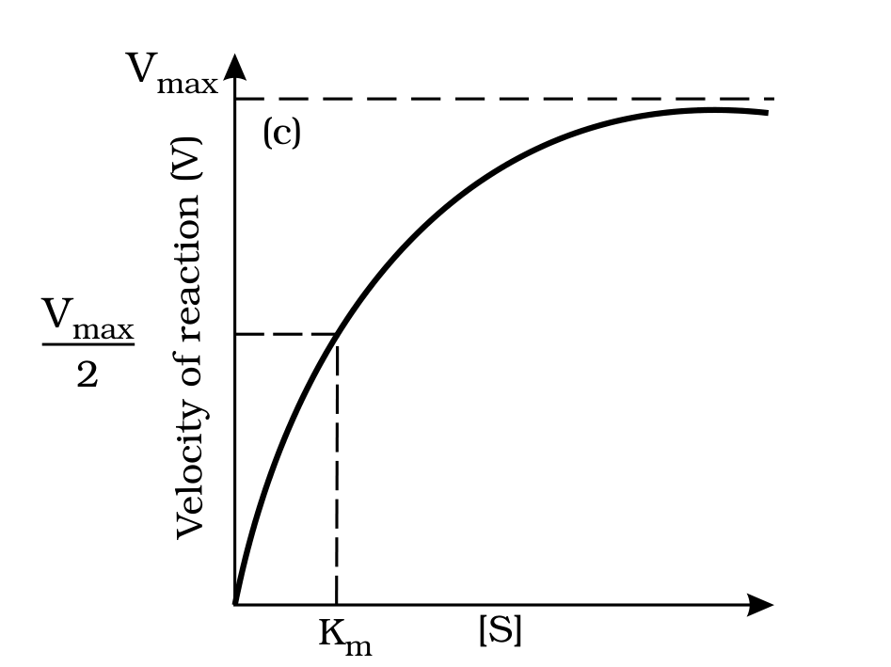
Fig. 9.5 (c) - Effect of change in substrate concentration on enzyme activity: velocity rises then plateaus at Vmax.
Labels printed in the figure: Vmax; Velocity of reaction (V); Km
Figure 9.5 - Effect of change in: (a) pH (b) Temperature and (c) Concentration of substrate on enzyme activity.
• The activity of an enzyme is also sensitive to the presence of specific chemicals that bind to the enzyme. When the binding of the chemical shuts off enzyme activity, the process is called inhibition and the chemical is called an inhibitor.
When the inhibitor closely resembles the substrate in its molecular structure and inhibits the activity of the enzyme, it is known as a competitive inhibitor. Due to its close structural similarity with the substrate, the inhibitor competes with the substrate for the substrate-binding site of the enzyme. Consequently, the substrate cannot bind and the enzyme action declines - e.g., inhibition of succinic dehydrogenase by malonate, which closely resembles the substrate succinate in structure. Such competitive inhibitors are often used in the control of bacterial pathogens.
9.8.5 | Classification and Nomenclature of Enzymes

Thousands of enzymes have been discovered, isolated and studied. Most of these enzymes have been classified into different groups based on the type of reactions they catalyse. Enzymes are divided into 6 classes, each with 4-13 subclasses, and named accordingly by a four-digit number.
Class | Reaction catalysed
Oxidoreductases / dehydrogenases | Catalyse oxidoreduction between two substrates S and S', e.g., S reduced + S' oxidised -> S oxidised + S' reduced.
Transferases | Catalyse a transfer of a group G (other than hydrogen) between a pair of substrates S and S', e.g., S-G + S' -> S + S'-G.
Hydrolases | Catalyse hydrolysis of ester, ether, peptide, glycosidic, C-C, C-halide or P-N bonds.
Lyases | Catalyse removal of groups from substrates by mechanisms other than hydrolysis, leaving double bonds.
Isomerases | Include all enzymes catalysing inter-conversion of optical, geometric or positional isomers.
Ligases | Catalyse the linking together of 2 compounds, e.g., joining of C-O, C-S, C-N, P-O etc. bonds.

[MEMORY AID - not in NCERT] Six enzyme classes - Oxidoreductases, Transferases, Hydrolases, Lyases, Isomerases, Ligases. Mnemonic: "Over The Hill, Little Indians Ligate." (memory aid, not in NCERT).

9.8.6 | Co-factors

Enzymes are composed of one or several polypeptide chains. However, there are a number of cases in which non-protein constituents called co-factors are bound to the enzyme to make the enzyme catalytically active. In these instances, the protein portion of the enzyme is called the apoenzyme.
Three kinds of cofactors may be identified: prosthetic groups, co-enzymes and metal ions.
• Prosthetic groups are organic compounds and are distinguished from other cofactors in that they are tightly bound to the apoenzyme. For example, in peroxidase and catalase, which catalyse the breakdown of hydrogen peroxide to water and oxygen, haem is the prosthetic group and it is a part of the active site of the enzyme.
• Co-enzymes are also organic compounds but their association with the apoenzyme is only transient, usually occurring during the course of catalysis. Co-enzymes serve as co-factors in a number of different enzyme-catalysed reactions. The essential chemical components of many coenzymes are vitamins, e.g., coenzyme nicotinamide adenine dinucleotide (NAD) and NADP contain the vitamin niacin.
• Metal ions: a number of enzymes require metal ions for their activity which form coordination bonds with side chains at the active site and at the same time form one or more coordination bonds with the substrate, e.g., zinc is a cofactor for the proteolytic enzyme carboxypeptidase.
Catalytic activity is lost when the co-factor is removed from the enzyme, which testifies that they play a crucial role in the catalytic activity of the enzyme.
QR | Quick Recap

Despite a bewildering diversity of living organisms, their chemical composition and metabolic reactions are remarkably similar. Qualitatively the elemental composition of living tissue and of non-living matter look alike, but a closer examination shows the relative abundance of carbon, hydrogen and oxygen is higher in living systems than in inanimate matter. The most abundant chemical in living organisms is water.
• Small molecules. There are thousands of low-molecular-weight (under 1000 Da) biomolecules - amino acids, monosaccharide and disaccharide sugars, fatty acids, glycerol, nucleotides, nucleosides and nitrogen bases. There are 20 types of amino acids and 5 types of nucleotides. Fats and oils are glycerides in which fatty acids are esterified to glycerol; phospholipids contain, in addition, a phosphorylated nitrogenous compound.
• Macromolecules. Only three types are found in living systems - proteins, nucleic acids and polysaccharides; lipids, because of their association with membranes, separate into the macromolecular fraction. Biomacromolecules are polymers made of building blocks which are different, so proteins are heteropolymers of amino acids and nucleic acids (RNA and DNA) are composed of nucleotides. Biomacromolecules have a hierarchy of structures - primary, secondary, tertiary and quaternary.
• Functions. Nucleic acids serve as the genetic material, carrying hereditary information passed from the parental generation to the progeny. Polysaccharides are components of the cell wall in plants and fungi and of the exoskeleton of arthropods, and are also storage forms of energy (e.g., starch and glycogen). Proteins serve a variety of cellular functions - many are enzymes, some antibodies, some receptors, some hormones and some structural proteins. Collagen is the most abundant protein in the animal world and RuBisCO (Ribulose bisphosphate Carboxylase-Oxygenase) is the most abundant protein in the whole of the biosphere.
• Enzymes. Enzymes are proteins which catalyse biochemical reactions in the cells, while ribozymes are nucleic acids with catalytic power. Proteinaceous enzymes exhibit substrate specificity, require an optimum temperature and pH for maximal activity, and are denatured at high temperatures. Enzymes lower the activation energy of reactions and thereby enhance their rate greatly.
A | Appendix - Terms Assumed by the NCERT Exercises

This appendix records what the chapter itself supplies for each exercise question. Where a question assumes information the chapter does not contain, that part is flagged as beyond this chapter rather than answered from outside the source (Rule 5).
• Q1 Macromolecules. Defined in 9.3: molecules of the acid-insoluble fraction (over ~10,000 Da, polymeric). Examples are the four acid-insoluble classes - proteins, nucleic acids, polysaccharides and lipids. Note the chapter's own tension: the summary counts only three macromolecules because 'Lipids are not strictly macromolecules'.
• Q2 Tertiary structure. Defined in 9.7: the long chain folded upon itself like a hollow woollen ball, giving a 3-D shape, absolutely necessary for biological activity.
• Q3 Ten small-molecular-weight biomolecules. The chapter supplies the biomolecules (Figure 9.1) and the size criteria (18-800 Da acid-soluble; under 1000 Da micromolecules). The industry and buyer half is beyond this chapter.
• Q4 Proteins as therapeutic agents. The chapter gives protein functions (Table 9.5: insulin as hormone, antibody, trypsin as enzyme). The therapeutic and cosmetic applications are beyond this chapter.
• Q5 Composition of triglyceride. In 9.1: fatty acids esterified to glycerol, in the mono/di/tri series; Figure 9.1 (c) shows a triglyceride (R1, R2, R3 are fatty acids).
• Q6 Ball-and-stick models. An activity; 'ball and stick' is not a chapter term, though Figure 9.3 (a) is drawn as a ball-and-stick chain. Pointed at the chapter's structural plates (Figures 9.1 and 9.3); the model-building itself is beyond this chapter.
• Q7 Structure of alanine. Named in the body and drawn in Figure 9.1 (b); in words, it is an alpha-amino acid on a substituted methane with four substituents (H, -COOH, -NH2 and R), the R group here being a methyl group.
• Q8 Gums. Gums appear as secondary metabolites (9.2) and in Table 9.3 ('Rubber, gums, cellulose'). What gums are made of, and any comparison with Fevicol, are beyond this chapter.
• Q9 Qualitative tests. The chapter's one colour test is the starch-I2 blue reaction (9.5), which is for a polysaccharide. Tests for proteins, fats and amino acids are beyond this chapter.
• Q10 Cellulose vs paper tonnage. The chapter has cellulose in cell walls, paper as cellulosic, and RuBisCO as the biosphere's most abundant protein, but no tonnage figures - the quantitative comparison is beyond this chapter.
• Q11 Properties of enzymes. Scattered across 9.8-9.8.6: proteinaceous (with ribozyme exception), active-site fit and substrate specificity, lower activation energy, high catalytic rate, optimum temperature and pH, denaturation by heat, thermal stability in thermophiles.

